CHAPTER I: INTRODUCTION 2

1.1 Introduction 3

1.2 Objective of the Project 3

1.3 Methodology/Procedure 3

1.4 Project Framework 3

1.5 Data and Information 3

1.6 Tools Used 4

1.7 Testing 4

1.8 Unit Testing 4

1.8.1 Integration Testing 5

1.8.2 System Testing 5

CHAPTER II: TASK AND ACTIVITIES PERFORMED 5

2.1 System Analysis 5

2.2 Problem Analysis 6

2.3 Design and Development Problem 6

2.4 Feasibility Analysis 6

2.4.1 Economical Analysis 6

2.4.2 Software Analysis 7

2.4.3 Data Conversion 7

2.4.4 Operational Feasibility 7

2.5 Use case Diagram 8

2.6 Sequence Diagram 8

2.7 Data Flow Diagram 10

2.9 ER Diagram 10

2.10 Flow Chart 11

2.11 Gantt Chart 12

2.12 Application’s Output 13

2.12.1 Frontend 13

2.12.2 Backend 15

List of Figure

Figure 1: Use Case Diagram 8

Figure 2:Sequence Diagram 9

Figure 3: Data Flow Diagram 10

Figure 4: ER Diagram 10

Figure 5: Gantt Chart 12

# CHAPTER I: INTRODUCTION

## Introduction

Nowadays, there is Online Car Rental which gives much benefit to user. A rental service is a service which customers arrive to request the hire of a rental unit. It is more convenient than carrying the cost of owning and maintain the unit. A car rental is a company that rent automobiles for short period of time for a fee for few hours or a few days or a week.

It helps to book the cars or vehicles online rather than using the traditional manual system of vehicle reservation. This eliminates the risk of erroneous booking and reduce overall lead time and ensures growth in customer satisfaction. They can book any car according to their brands and price.

## Objective of the Project

The objective of the project is to automate vehicle rental ad reservation so that the customers do not need to call and spend unnecessary time to reserve a vehicle.

* To transform the manual process of hiring car to a computerize system
* To validate the Rental car system using user satisfaction test
* To produce the documentation such as Software Requirement Specification(SRS), Software Design Description as system development reference

## 1.3 Methodology/Procedure

* For the development of project the designing of database was done on PHPMYADMIN, back end was coded in basic PHP and for frontend we used the same basic PHP codes.
* Software methodologies are concerned with the process of creating software – not so much the technical side but the organizational aspects. Several software development approaches have been used since the origin of information technology.

## 1.4 Project Framework

A framework is a standardized set of concepts, practices, and criteria for dealing with a common type of problem, which can be used as a reference to help us approach and resolve new problems of a similar nature.

The aim of framework is to provide a common structure so that developers don’t have to redo it from scratch and can reuse the code provided. In this way, frameworks allows us to cut out much of the work and save a lot of time

## 1.5 Data and Information

Data collection plays an important role in a projects succession and also it plays an inevitable role in the timely completion of the project. The data in the project includes contact information of the clients and their respective feedbacks/complaints which is stored in a database. To assure safety, only the admin has proper access to the information provided by the clients.

## 1.6 Tools Used

* **Xampp:**
  + **Apache:**
    - (Application Server) Apache , often referred to as Server, is an open-source Java Servlet Container developed by the Apache Software Foundation.
  + **MySqlServer:** 
    - It handles larege databases much faster than existing solutions.
    - It consists of multi-threaded SQL server that supports different back ends, several different client programs and libraries, administrative tools, and application programming interfaces (APIs)
    - Its connectivity, speed, and security make MySQL Server highly suited for accessing databases on the Internet.
* **Sublime Text 3.1.1-** Sublime Text is a sophisticated text editor for code, markup and prose. You'll love the slick user interface, extraordinary features and amazing performance.
* **Web browsers**: Google Chrome,Mozilla Firefox, Opera and Internet Explorer.
* **Git Hub**: GitHub Inc. is a web-based hosting service for version control using Git. It is mostly used for computer code. It offers all of the distributed version control and source code management functionality of Git as well as adding its own features.

## 1.7 Testing

Testing is evaluation of the software against requirements gathered from users and system specifications. Testing identifies important defects, flaws, or an error in the application code that must be fixed .It also assesses the feature of a system. Testing assesses the quality of the product.

## 1.8 Unit Testing

Unit testing refers to the testing certain functions and areas of the code. It gives the ability to verify that all the functions work as expected. Eventually, it helps to identify failures in the algorithms as well as logic to help improve the quality of the code that composes a certain function.

## 1.8.1 Integration Testing

Integration testing is basically a logical extension of unit testing. In simple words, two tested units are combined into a component and the interface between them is tested. It identifies problems that occur when different units are combined. The different modules of this project have undergone integration testing while being merged.

## 1.8.2 System Testing

System testing tests the behavior of whole system as defined by the scope of the development project. It might include tests based on risks as well as requirement specifications, business process, use cases or other high level descriptions of system behavior, interactions with the operating systems and system resources. It is most often the final test performed to verify that the system meets the specification and its objectives. System testing has been performed at the completion of each feature and is still taking place to make improvements on the existing system.

# 

# CHAPTER II: TASK AND ACTIVITIES PERFORMED

## 2.1 System Analysis

System Analysis is a detailed study of the various operations performed by a system and their relationships within and outside of the system. Here the key question is- why all problems exist in the present system? What must be done to solve the problem? Analysis begins when a user or manager begins a study of the program using existing system. During analysis, data collected on the various files, decision points and transactions handled by the present system. The commonly used tools in the system are Data Flow Diagram etc. Training, experience and common sense are required for collection of relevant information needed to develop the system. The success of the system depends largely on how clearly the problem is defined, thoroughly investigated and properly carried out through the choice of solution. A good analysis model should provide not only the mechanisms of problem understanding but also the frame work of the solution. Thus it should be studied thoroughly by collecting data about the system. Then the proposed system should be analyzed thoroughly in accordance with the needs. System analysis can be categorized into four parts.

* System planning and initial investigation
* Applying analysis tools for structured analysis
* Feasibility study
* Cost/ Benefit analysis.

## 2.2 Problem Analysis

This stage there is no existing system previously; we are developing a new system. Till now no system is available with this type of features and facilities. This system is developed for the all types of users with highly flexible and configurable product is envisaged to ensure global marketing

## 2.3 Design and Development Problem

* Problem in running XAMPP.
* To debug the error during the development.
* To show a relationship between entity.
* Minor error with database table.

## 2.4 Feasibility Analysis

A feasibility analysis is conducted once the problem is clearly understood. The purpose of the study is to determine whether the problem is worth solving. It is an analysis and evaluation of a proposed project to determine if it is technically feasible.

## 2.4.1 Economical Analysis

The economic feasibility of a system is used to evaluate the benefits achieved from and the costs incurred for the project or system. This is done by a process called cost benefit analysis. It provides tangible and intangible benefits like reduction in cost, more flexibility, faster activities, proper database management, etc.

The application is medium scale application and is economically feasible for us to accomplish it. This involves cost benefits analysis. Thus there is no problem of high cost and cost benefits analysis.

## 2.4.2 Software Analysis

* Consumes a long-time for development of web application.
* Research and analysis cost to determine the actual need in real world.
* Implementation of application in the server and cost associated with the space in server.

## 2.4.3 Data Conversion

Another cost associated while implementing this web application is the data conversion. The previously used software database must be stored and backup such that there will be no loss in implementing a new web application which consumes time as well as money.

## 2.4.4 Operational Feasibility

The system is operational feasible as the system can be operate by normal users with basic computer skills without any additional trainings. We have developed this system with the willingness and ability to create, manage and operate the system which is easy for the end users to operate it.

## 2.5 Use case Diagram

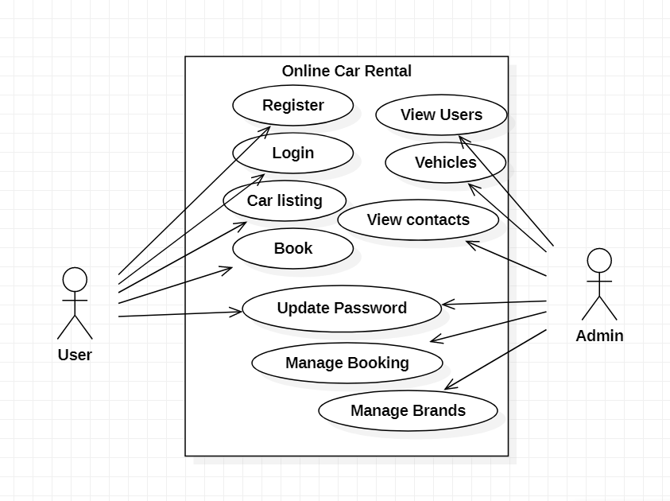

Figure 1: Use Case Diagram

Above figure represents Use Case Diagram of the project and is a useful technique for identifying, clarifying, and organizing system requirements. It describes how a user uses a system to accomplish a particular goal. Use cases help ensure that the correct system is developed by capturing the requirements from the user's point of view.

## 2.6 Sequence Diagram

A sequence diagram is a type of interaction diagram because it describes how—and in what order—a group of objects works together. A sequence diagram specifically focuses on lifelines, or the processes and objects that live simultaneously, and the messages exchanged between them to perform a function before the lifeline ends.

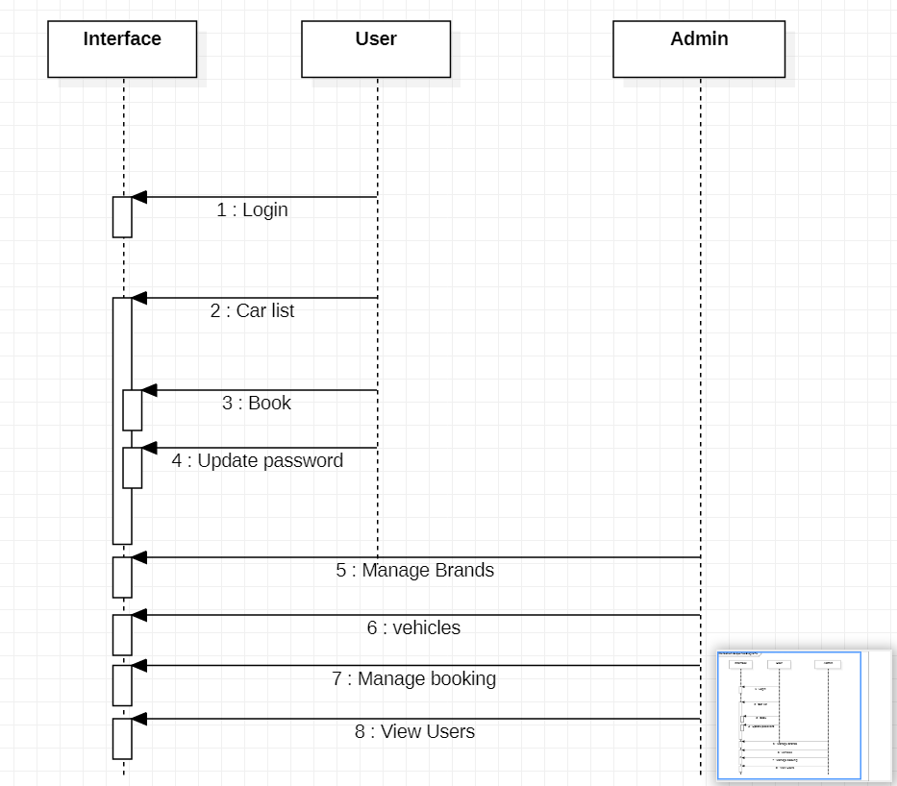

Figure 2:Sequence Diagram

Above diagram represents Sequence Diagram of the project which is a type of interaction diagram because it describes how—and in what order—a group of objects works together. A sequence diagram specifically focuses on lifelines, or the processes and objects that live simultaneously, and the messages exchanged between them to perform a function before the lifeline ends.

## 2.7 Data Flow Diagram

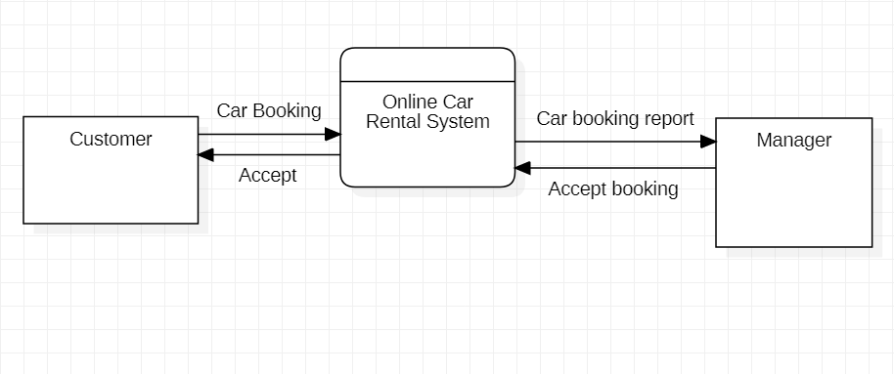

Figure 3: Data Flow Diagram

Above Data Flow Diagram, explains the overall structure of the system. It shows how and what types of services the client chooses and the amount of admin interaction in it.

## 2.9 ER Diagram

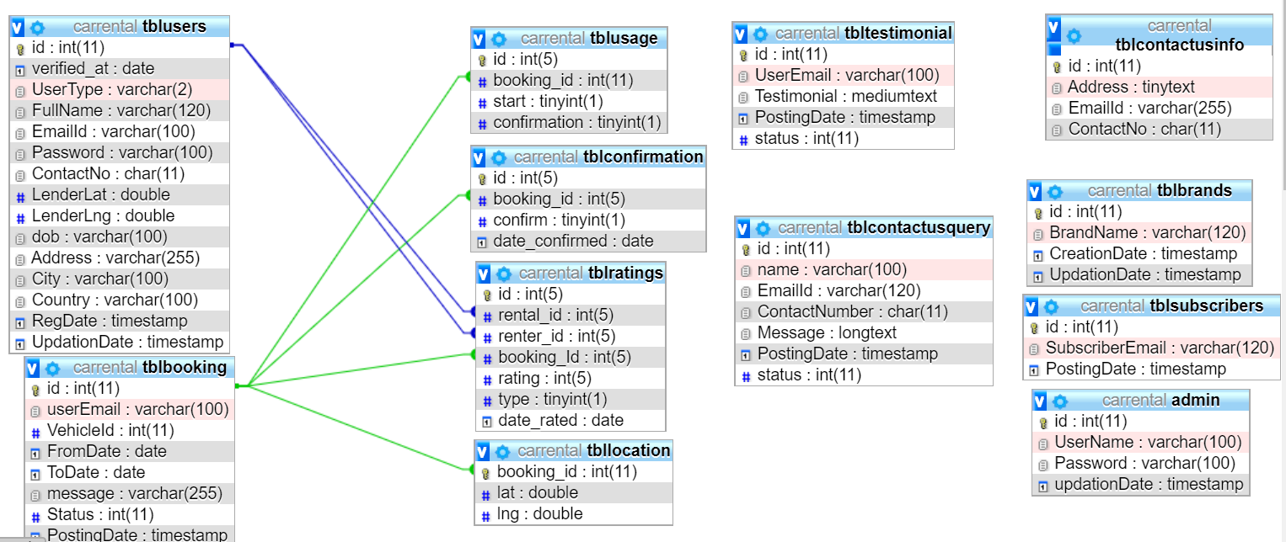

Figure 4: ER Diagram

ER diagram show all the relationships between entity sets stored in the database. It illustrates the logical structure of the database. It helps to visualize how data is connected in general ways.

## 2.10 Flow Chart

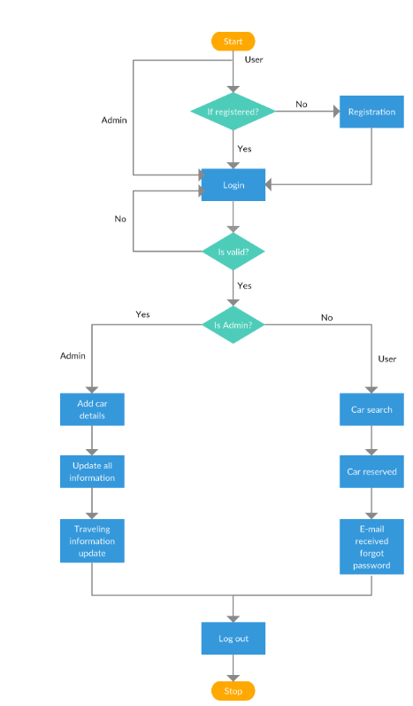

## 2.11 Gantt Chart

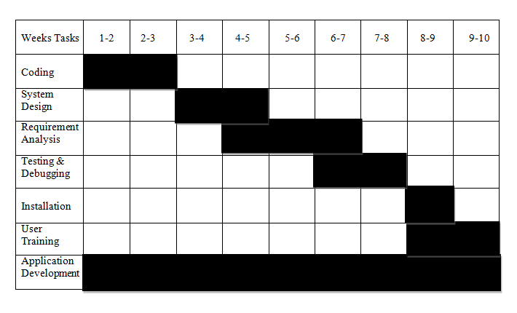

Figure 5: Gantt Chart

A Gantt chart illustrates how the project will run. It communicates with the client and shows them the expected date of project completion. It helps you assess how long a project should take, determine the resources needed, and plan the order in which you'll complete task.

## 2.12 Application’s Output

## 2.12.1 Frontend

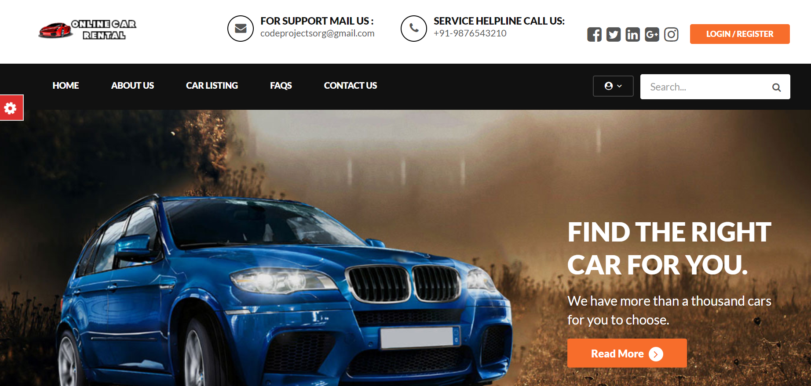Home Page

Login Page

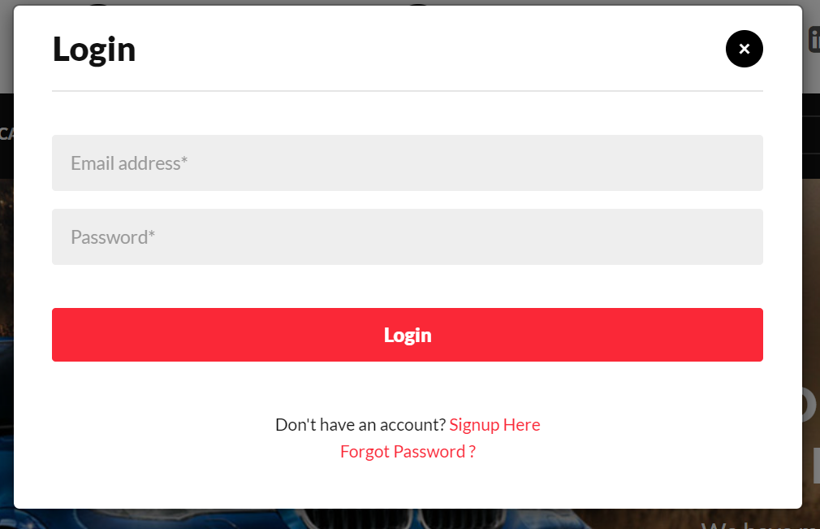

## 2.12.2 Backend

Admin Login page

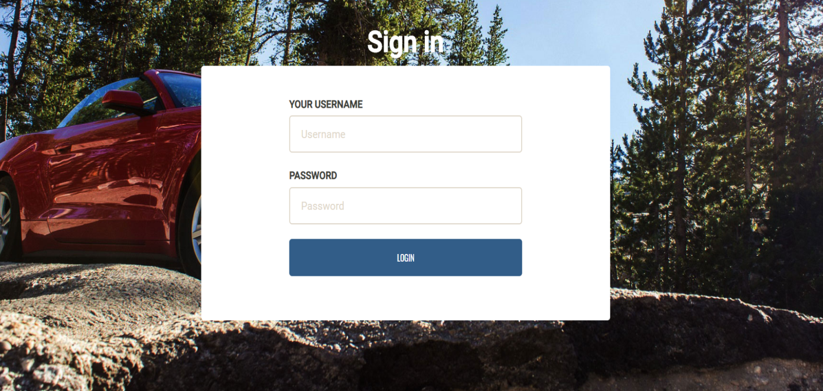

Manage Vehicles

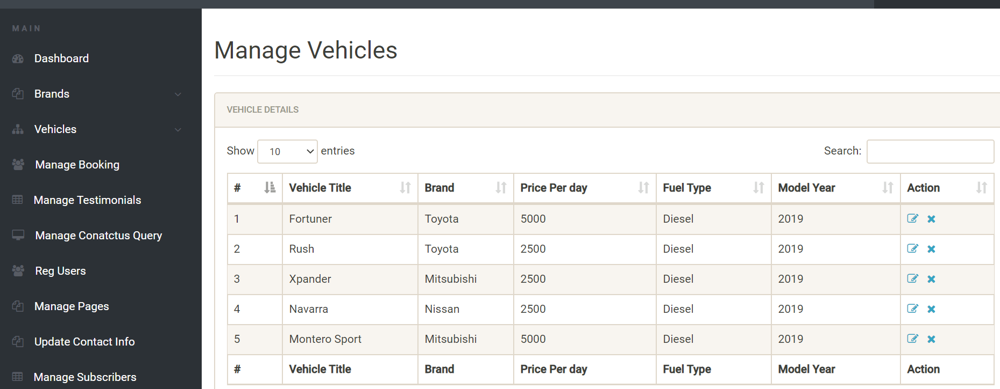

Add Brand

